Analysis and Future Risk Prediction of Diabetes Mellitus

Praffulla Kumar Dubey
Computer Science and Engineering
SRM Institute of Science and Technology, India
praffullakrdubey@gmail.com
Udbhav Naryani
Computer Science and Engineering
SRM Institute of Science and Technology, India
udbhav.naryani@gmail.com
Medhavi Malik
Computer Science and Engineering
SRM Institute of Science and Technology, India
medhavimalik28@gmail.com

ABSTRACT
The number of patients suffering from diabetes in India are increasing rapidly. One of the major reasons behind this can be that most of the population does not take regular check-ups for diabetes. Hence, they are unable to take proper precautions and have a risk of getting diabetes in the future. The current methodologies followed by the doctors are manual and can be time consuming. The objective of this paper is to predict the whether the patient is diabetic or not by applying various machine learning and deep learning algorithms like Logistic regression, Support Vector Machines, k-NN, Naive Bayes, Decision Tree, Random Forest, Perceptron and Multilayer Perceptron on Pima Indian diabetes dataset and improve the accuracy of model.

KEYWORDS: SVM, Logistic Regression, Naïve Bayes, Decision Tree, k-NN, Random Forest, Perceptron, Multilayer Perceptron.

I. INTRODUCTION

Presently in the world, there are various chronic diseases that are distributed throughout the developed as well as developing countries. Diabetes mellitus, commonly known as diabetes is one of these chronic diseases and it is responsible for cutting human life at an early age [1]. It is a group of metabolic disease which marks high blood sugar levels over a prolonged period [2]. It has been observed that diabetes disease is on a rapid increase in Asian country like India. Various health sectors are working to predict these chronic diseases in future hence saving the human life. Exercise plays an important role in recovering diabetes and if a diabetic person eats healthy food and does exercise regularly then there are chances of recovery for them. Various human body parts like eye, heart, nerves and kidney can be damaged by diabetes disease [12]. Currently, in order to diagnose diabetes, the doctors take patients sample of blood and measure the sugar concentration that is present in their blood. This methodology followed by the doctors is time consuming and some other features are like age, blood pressure, body mass index (BMI) and insulin. There are chances for a person to be diabetic in future if an ancestor of the patient shows a presence of diabetes [2]. Diabetes of two types, Type 1 and Type 2 diabetes. At present there are no intrusive techniques to predict whether the patient has type 1 diabetes. Type 2 diabetes is non-insulin-dependent diabetes and it has been observed that it is more common in Pima Indians than it is in any other population on earth. Type 2 diabetes can be cured if it is detected at an early age.

II. LITERATURE SURVEY

S. Barik et al., [3] in their paper “Analysis of Prediction Accuracy of Diabetes Using Classifier and Hybrid Machine Learning Techniques” used XGBoost and Random Forest algorithm and they did not perform data cleaning on the dataset. They achieved the highest accuracy of 74.1 % with XGBoost algorithm. H. Balaji et al., [2] in their paper “Optimal predictive analytics of pima diabetics using deep learning” used only Recurrent Neural Networks for training and testing their models. A. Mohebbi et al., [4] in their paper “A deep learning approach to adherence detection for type 2 diabetics” used Convolutional Neural Networks and the dataset used by the authors was very small. Y. N. and SriPreethaa [5] in their paper “Diabetes prediction in healthcare systems using machine learning algorithms on hadoop clusters” used only Random Forest Algorithm on Hadoop Cluster and the authors discussed the information gain methods for feature selection but they did not mention the pre-processing steps used. F. Mercaldo et al., [6] in their paper “Diabetes mellitus affected patients classification and diagnosis through machine learning techniques” used Hoeffding Tree, JRip, BayesNet, Random Forest. The authors used WEKA tool for analysis and prediction but they did not mention the pre-processing steps and the highest accuracy achieved by the authors was 76 % using Hoeffding Tree. S. Lekha and Suchetha M. [7] in their paper “Real-time non-invasive detection and classification of diabetes using modified convolution neural network” used one dimensional modified Convolution Neural Network on the dataset having eleven healthy, nine diabetic patients of type 2 and five diabetic patients of type 1. No pre-processing was performed on the dataset and the dataset used by the authors were very small. J Pradeep and Saminathan [8] in their paper “Performance analysis of classifier models to predict diabetes mellitus” used J48, KNN and Random Forest algorithm for prediction and they got 73.8 % accuracy with J48 algorithm. The authors did not mention the data pre-processing techniques and methodology used by them. A. Iyer et al., [9] in their paper “Diagnosis of diabetes using classification mining techniques” used only Naive Bayes and Decision Tree algorithms and they got an accuracy of 79.5% from Naive Bayes classifier. Pre-processing and data-set transformation was done using WEKA tool. Q. Zou et al., [10] in their paper “Predicting diabetes mellitus with machine learning techniques.” used Neural Networks, Random Forest and Decision Tree algorithms. They achieved the highest accuracy of 76% with Neural Networks. MATLAB tool was used for model creation by the authors. S Nanda et al., [11] in their paper “Prediction of gestational diabetes mellitus by maternal factors and biomarkers at 11 to 13 weeks” used only Logistic Regression for prediction and the accuracy of their model was not mentioned.

III. ALGORITHMS USED

In this paper, we propose to use supervised machine learning algorithms like Support Vector Machine, Logistic Regression, Decision Tree, Naive Bayes, Random forest and k-NN and deep learning algorithms like Perceptron and Multilayer Perceptron for diabetes prediction. All the algorithms used for this research are explained in the model below.

A. Supervised learning
Machine learning is considered as one of the fastest growing domains of computer science and it can also refer to automated detection of patterns in data that are meaningful. There are many far reaching applications like predicting various outcomes. The algorithms of machine learning are organized into a taxonomy based on the desired outcome of the algorithm [14]. The task of generating a function that is used to map the given inputs to the expected outputs is known as supervised learning. It deduces a function from the marked training data consisting of various training examples sets. Supervised learning is very common in problems like classification because the goal is often to get the machine learn a classification system that is created [15]. Supervised learning technique is used for analyzing the training data of the dataset and create a deduced function for mapping the new instances and this technique allows the learning algorithm used to uniquely identify class labels for hidden instances. Supervised learning algorithms mainly deals with classification algorithms which includes the below mentioned algorithms:

a. Support Vector Machine
One of the most recent supervised machine learning techniques is Support Vector Machine also termed as SVM [16]. SVM algorithms are very closely related to deep learning neural networks algorithm “multilayer perceptron”. SVM converts real data into a data containing data with high dimension using non-linear mapping. SVM can be used for classification as well as numerical prediction. SVM has a margin on either sides of a hyperplane and this hyperplane separates two data classes. The expected generalization error can be minimized by increasing the margin and increasing the distance between instances on either sides and the hyperplane.

b. K-nearest neighbor

c. Naive Bayes classifier

d. Random Forest Classifier

e. Decision Tree

f. Logistic Regression

B. Deep Learning
Recently, various machine learning models developed are being used for forecasting the results or in a simpler term these models are being used for prediction of results. These models have become very famous in the medical diagnosis field also and medical diagnosis can be termed as one of the main problems in medical applications. There has been a significant research for the improvement of neural networks for medical diagnosis as neural networks enlarge the accuracy and neutrality of the medical diagnosis [17]. There are many neural networks like Artificial Neural Networks, Convolution Neural Networks and Recurrent Neural Networks. Artificial Neural Networks also termed as ANN contain various layers of nodes with computing data and these nodes are capable of processing information. These ANN can also find non linearities that are not originating as inputs and they are capable of clustering, association, function approximation and forecasting, and performing particularly parallel multi factorial analysis for modeling complex patterns, where there is less prior knowledge [18]. Today, artificial neural networks (ANN) are being preferred over other models because the non-linearity that they posses allow the data to be fitted more accurately, as ANN are noise-insensitive hence this leads to an accurate prediction irrespective of the measurement errors, ANN helps in fast processing and are hardware failure tolerant because of the presence of high parallelism, in the response to the changing environment ANN’s learning and the adaptability permits the models to update the model’s internal structure with response to the change in the environment [19]. In 1957, Frank Rosenblatt a notable psychologist in field of artificial intelligence introduced Perceptron and a perceptron learning rule based on the original MCP neuron was proposed by him. A perceptron can be defined as a neural network that is capable of doing some computations to detect various features or business intelligence in the data that has been provided as an input whereas a multilayer perceptron also termed as MLP can be defined as a class of feedforward ANN and it utilizes backpropagation for training which is a supervised learning technique.
a. Perceptron
The perceptron is defined as an algorithm for binary classifiers of supervised learning algorithms where a binary classifier is a function which is used for deciding whether an input provided by the user belongs to the specific class or not. It is a linear classification algorithm where a linear classification algorithm makes the predictions based on a linear predictor function combining a set of weights with a feature vector [21]. Perceptron is one of the simplest and first artificial neural networks. It is similar to logistic regression algorithm. It can learn separation feature space for two class classification tasks, although unlike logistic regression, it uses stochastic gradient descent optimization algorithm for learning purpose and perceptron does not predict calibrated probabilities [22].
a.1. Perceptron Algorithm
In the model as shown in figure 1, there are binary inputs (I_1, I_2, …., I_N) and same N number of weights (Weight_1, Weight_2, …, Weight_N) provided to the model. All the inputs are now multiplied and then summed up together. This sum is called as pre-activation function and denoted as “P”.

P = _{i = 1}∑^{n} Weight _{i} I _{i} = Weight^{T} I

Now we apply the activation function and this produces an activation which is termed as “A” and this activation function can also be termed as “step function”.

ϱ (y) = 1, when y >= 0
ϱ (y) = 0, when y < 0

The model generates an output 1 when the input is greater than or equal to 0 whereas, the output is 0 when input is less than 0.
A = ϱ (Weight^{T} I)
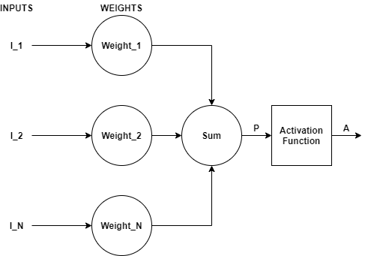
Fig 1. Perceptron

b. Multilayer Perceptron
The multilayer perceptron (MLP) algorithm is one of the most frequently used neural networks. Multilayer perceptron is considered as a class of feedforward artificial neural network [23]. Generally, the signals transmitted from the network are unidirectional i.e., from input to output. As there is no loop in multilayer perceptron, hence output does not affect the neuron and this architecture of multilayer perceptron is termed as feed-forward architecture. There are layers present in multilayer perceptron that do not have a direct connection to the environment and these layers are called as hidden layers. The input layer is the standalone layer of the network as it is the layer that provides input. The non-linear activation function provides all the strength to multilayer perceptron. We can use any of the non-linear functions except for polynomial function and most commonly used functions are single pole sigmoid and bipolar sigmoid function [20].
b.1. Multilayer Perceptron Algorithm
In the model as shown in figure 2, feed forward network is used. The main goal of feed forward network is to provide approximation for any function T (). Let for a classifier q = T * (I) that is mapping input I to output q, then multilayer perceptron finds the approximation by mapping q = T (I; θ) and it learns the best parameters. Multilayer perceptron consists of many functions together. A MLP network with 4 layers will have the following equation:
T (I) = T (4) (T (3) (T (2) (T (1) (I)))
and each layer is represented as:
q = A (Weight I P + Bias)
where,
A is activation function
Weight is weights in the layers
I is the input in form of vectors
Bias is the bias vector

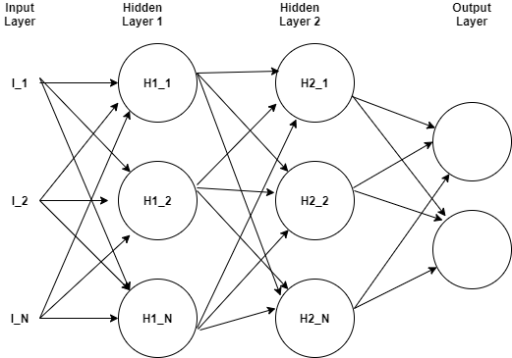
Fig 2. Multilayer Perceptron

IV. METHODOLOGY

Data science is a technique of gathering, processing and analyzes data i.e., combine programming, mathematics and statistics domain to extract insights and knowledge from the data. This technique plays an important role in different project as it improves the performance prediction of machine learning algorithms used i.e., help in predicting the outcome by providing input to the machine [13]. The methodology followed is explained below:
- Data Import: It is the step where we collect the dataset that is to be used for training and testing our machine learning model. The dataset can be collected from various resources like online or data stored in various databases. It is important to select the correct dataset as the selected dataset will be used for training the machine learning model hence if use incorrect model then we would not receive the required results from our trained machine learning model.
- Data Cleaning: Data cleaning plays an important role as the data is collected from various resources and hence the data in coarse in nature. This coarse data is termed as “dirty data”. The dirty data may contain some values that might not be required for the model training purpose hence that should be handled and we handle unrequired data in the data cleaning step. Also, the dataset may contain null values in it. It becomes important to handle null values because we can not use the dataset with null values. We can replace the null values with either mean, median or mode values.
- Data Visualization: In this technique we visualize the data present in the dataset by plotting various graphs. This technique makes analysis of data easy and helps us to find co-relation among various attributes present in the dataset.
- Data Analysis: Analyze the results of various graphs and gain knowledge about the different attributes of the dataset.
- Feature Scaling: As the dataset contains the data which is of different units, hence we need to scale the data present in the dataset into data of similar units and for this we use standard scaler to scale all the values. This step plays an important role in increasing the accuracy of the model.
- Select Machine Learning Algorithm: Select the best Machine/Deep learning algorithm (K-Nearest Neighbor, Support Vector Machine, Logistic Regression, Naïve Bayes, Random Forest, Decision Tree, Perceptron and Multilayer Perceptron) for creation of prediction model.
- Prediction Model: Create the prediction model for predicting diabetes.
- Design User Interface: Develop a Graphical User Interface (GUI) for the prediction model to be easily used by users.
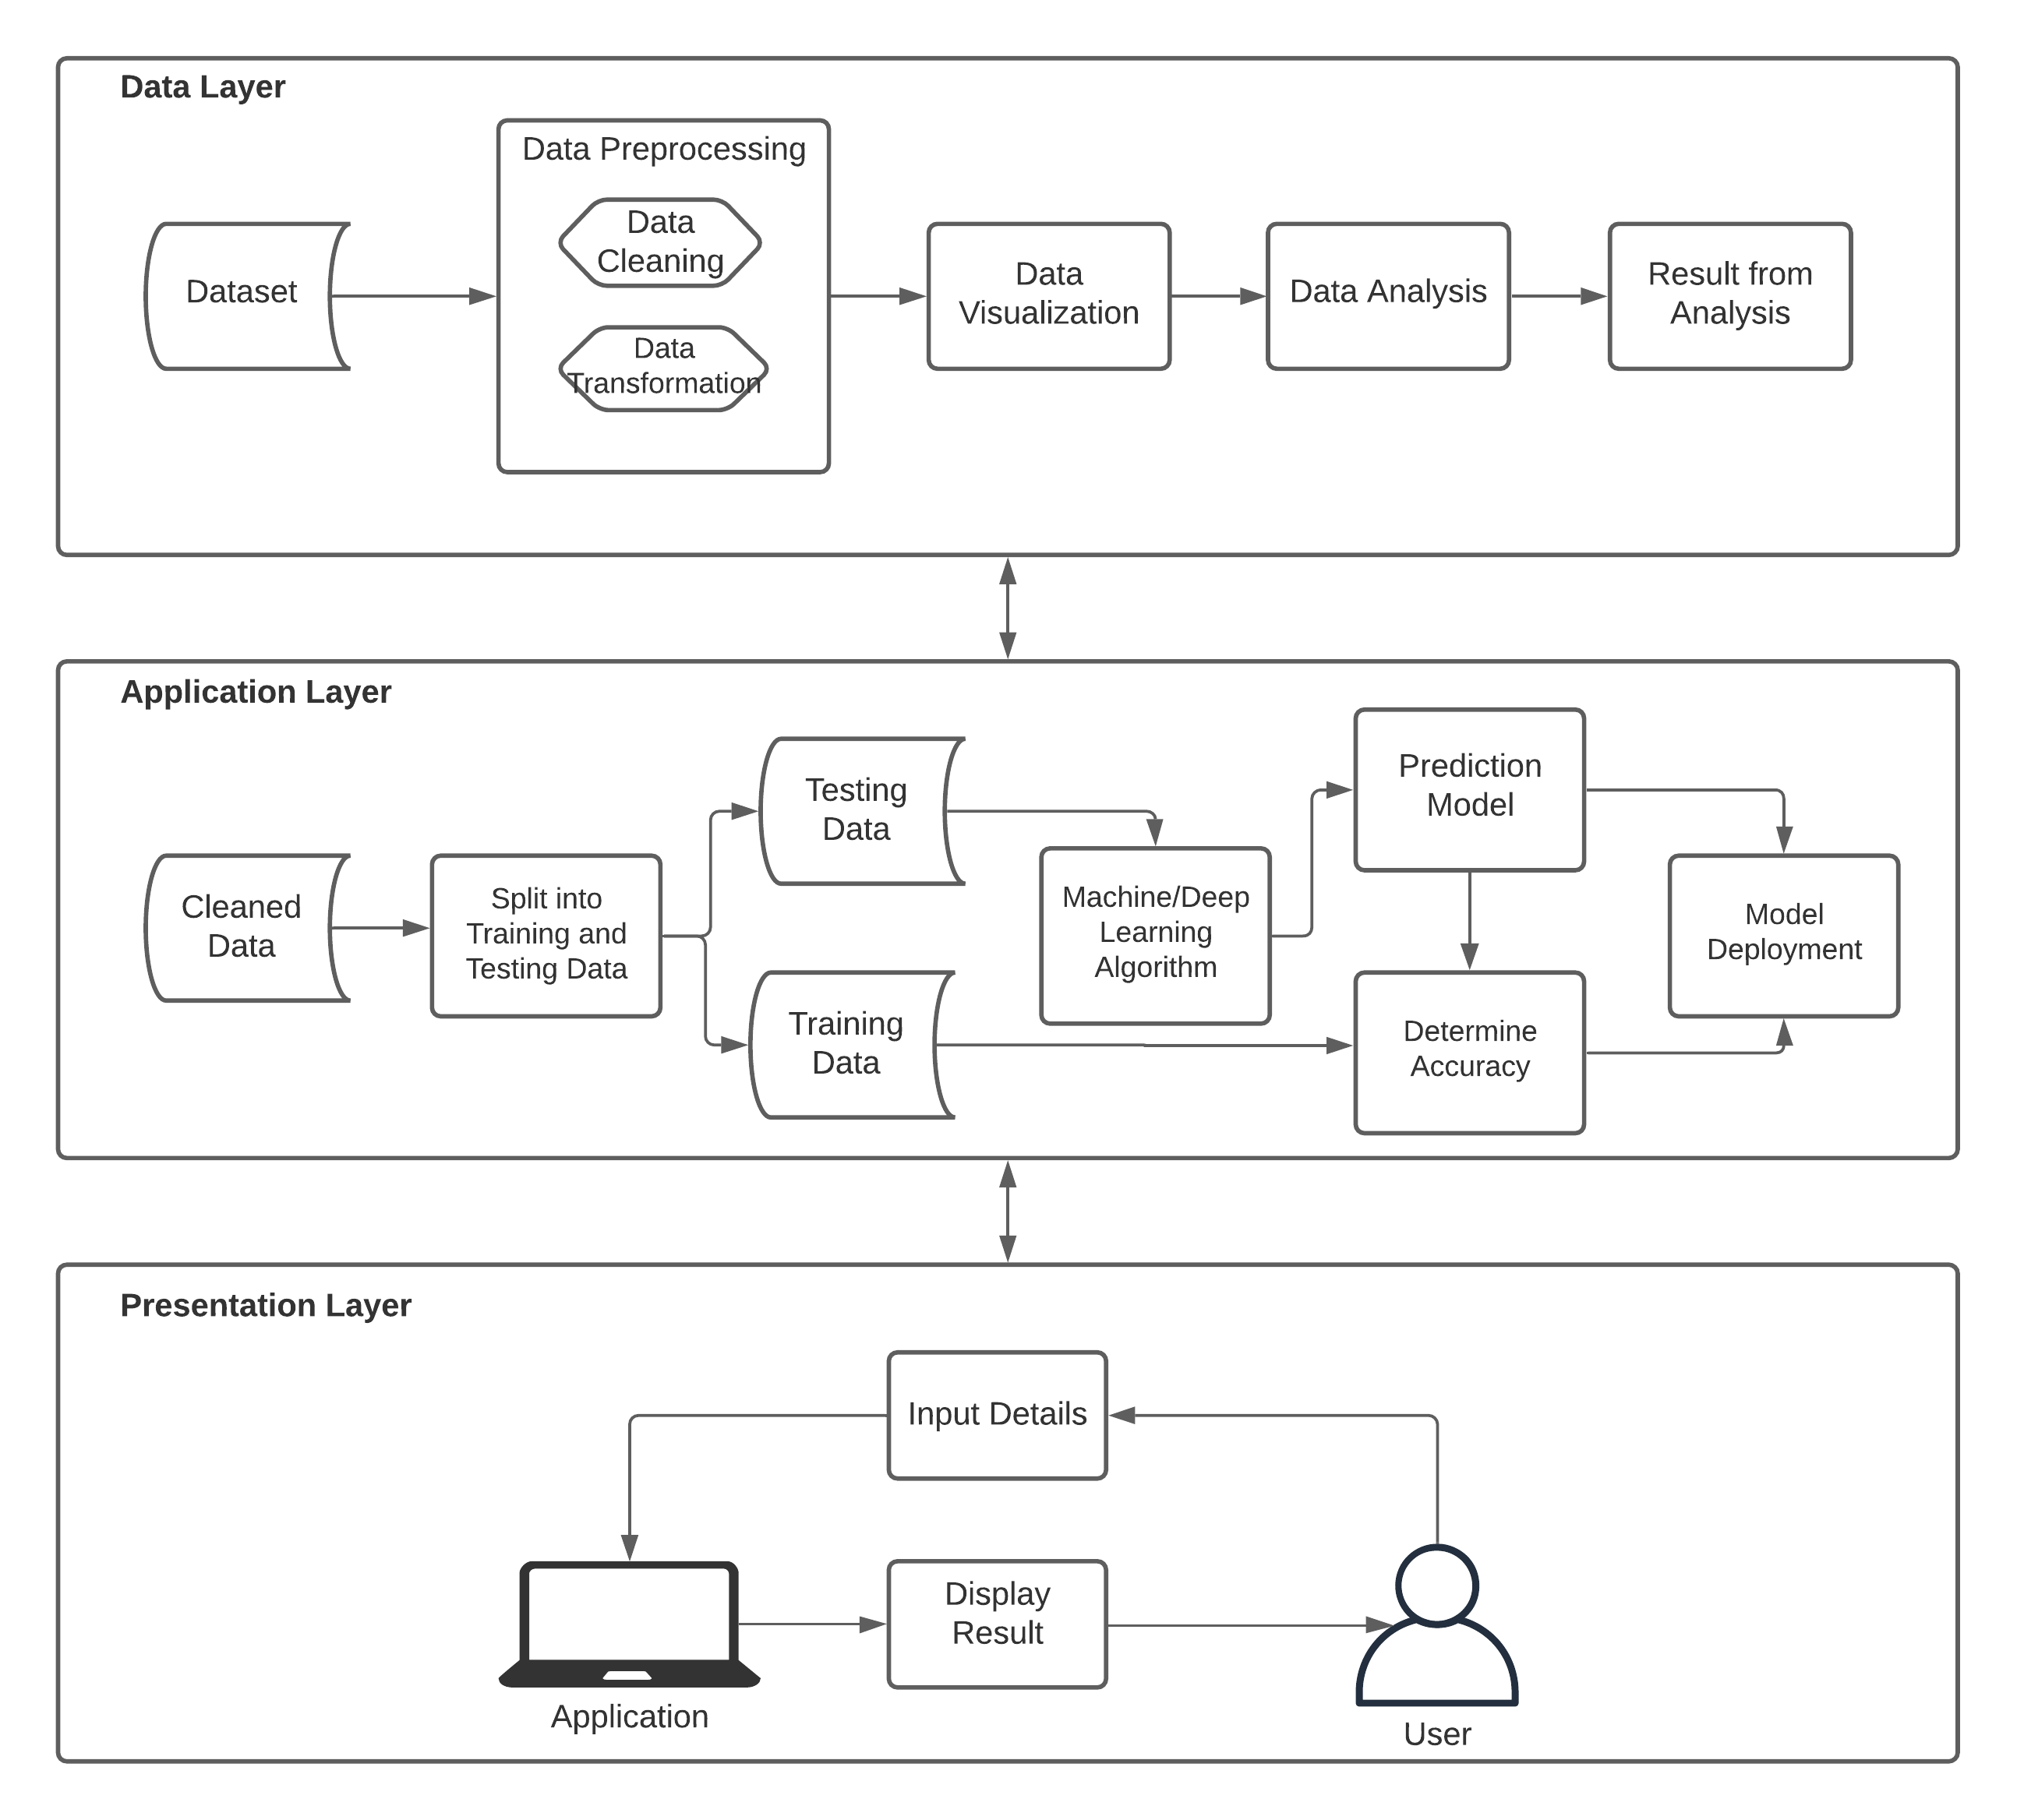
Fig 3. Methodology

V. PROPOSED ALGORITHM

Step 1: Collect match Statistics of various countries T20 cricket (RD₁, RD₂,….RD_{n} ) where RD=Resource Data
Step 2: Data Preprocessing
1) Cleaning of data i.e. cleaning of data
2) Normalization i.e. normalize the values
3) Transformation
4) Integration of the data
Step 3: The data is to be split into Training data and Test data for training the model
Step 4: Create model using Naïve Bayes Algorithm
model=sc.Naive Bayes(x_train)
Step 5: Apply Test data on model
test=sc.fit_transform(test)
model.fit(x_train,y_train)
prediction=model.predict(x_test)
Step 6: Predictive outcome
1) Knowledge Discovery in terms of various graphs like Histogram, Scatter Plot, Line Graph etc.
2) Performance Accuracy of model
3) Score prediction in term of overs and score of the team

VI. RESULT

In our project we have applied Support Vector Machine, Random Forest, Logistic Regression, k-NN and Naïve Bayes algorithm and after training our model on the data set we found that the accuracy of our model is approximate 71 percent for Naïve Bayes Algorithm, 66 percent for k-NN, 64 percent for Logistic Regression, 63 percent for Random Forest and 59 percent for Support Vector Machine. We found that using Naïve Bayes Algorithm we get the maximum accuracy for our model therefore we can conclude that using Naïve Bayes Algorithm we get more accurate results as compared to other algorithms used. Figure 1 shows the team with most number of IPL titles.

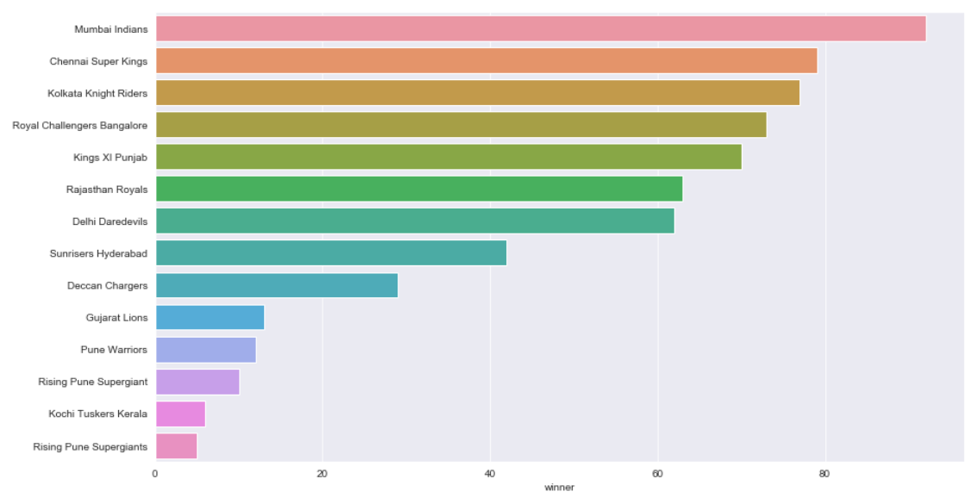

Fig 4. The most successful IPL Team till 2017

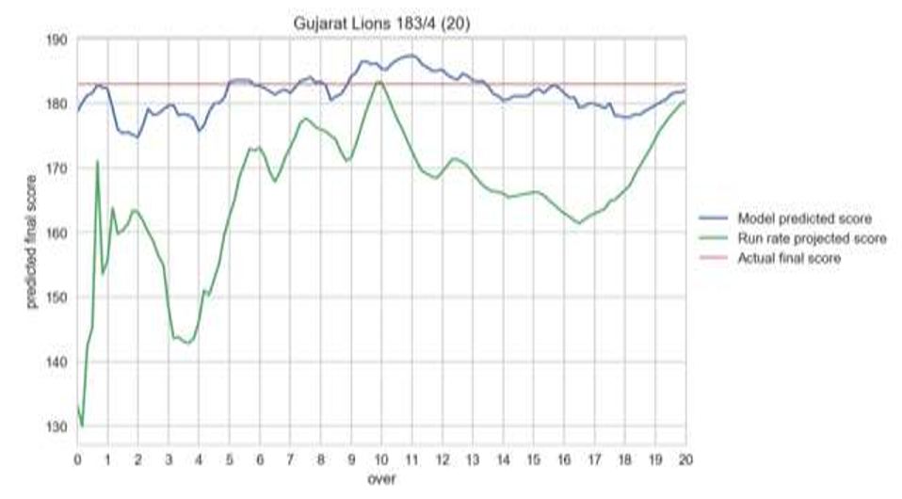
Fig 5. Performance of model trained
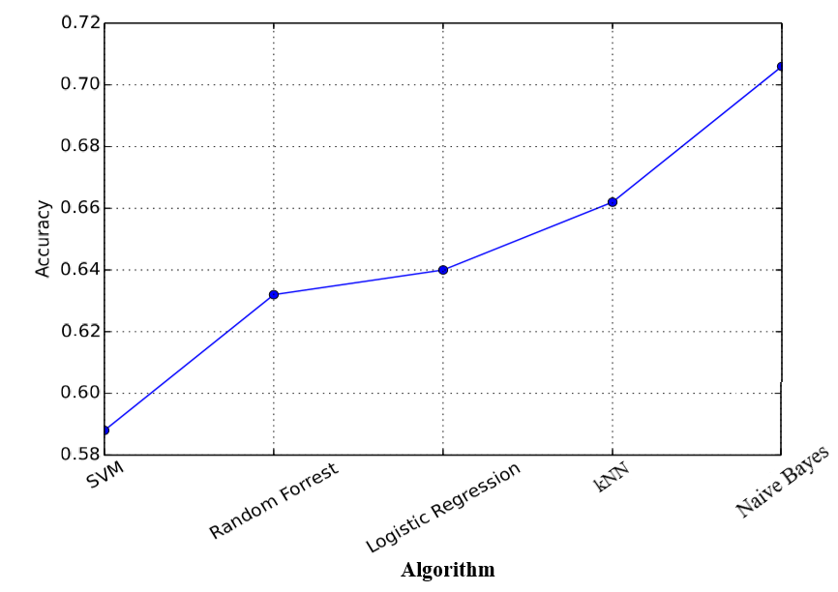
Fig 6. Accuracy of various classifiers applied

VII. CONCLUSION AND FUTURE SCOPE

The limitation in carrying out this project was access to the limited dataset. The next step for improving the accuracy of prediction model would be to test out the approaches and various techniques proposed in this paper using a larger dataset. Also, we can use attributes like daily food habits and exercise habits of persons for training the model as these attributes can affect whether a person has a risk of being diabetic or not. If Deep Neural network (Keras, Thaeno and Tensorflow) and unsupervised learning algorithms are implemented on a larger dataset, then the accuracy can even be higher. Also, similar model can be developed for other diseases like heart dieses, cancer, brain tumors, asthma and so on.

VIII. REFERENCES

[1] Alehegn, Minyechil & Joshi, Rahul & Mulay, Preeti. (2018). Analysis and prediction of diabetes mellitus using machine learning algorithm. International Journal of Pure and Applied Mathematics. 118. 871-878.
[2] Balaji, H. & Iyenger, N Ch Sriman Narayana & Caytiles, Ronnie. (2017). Optimal Predictive analytics of Pima Diabetics using Deep Learning. International Journal of Database Theory and Application. 10. 47-62. 10.14257/ijdta.2017.10.9.05.
[3] S. Barik, S. Mohanty, and D. Singh. Analysis of Prediction Accuracy of Diabetes Using Classifier and hybrid Machine Learning Techniques, pages 399-409. 01 2021.
[4] Mohebbi A, Aradottir TB, Johansen AR, Bengtsson H, Fraccaro M, Morup M. A deep learning approach to adherence detection for type 2 diabetics. Annu Int Conf IEEE Eng Med Biol Soc. 2017 Jul;2017:2896-2899. doi: 10.1109/EMBC.2017.8037462. PMID: 29060503.
[5] Y. N. and K. SriPreethaa. Diabetes prediction in healthcare systems using machine learning algorithms on hadoop cluster. Cluster Computing, 22, 01 2019.
[6] F. Mercaldo, V. Nardone, and A. Santone. Diabetes mellitus affected patients classification and diagnosis through machine learning techniques. Procedia Computer Science, 112:2519-2528, 12 2017.
[7] S. Lekha and S. M. Real-time non-invasive detection and classification of diabetes using modified convolution neural networks. IEEE Journal of Biomedical and Health Informatics, 22(5):1630-1636, 2018.
[8] J. p. Kandhasamy and S. Balamurali. Performance analysis of classifier models to predict diabetes mellitus. Procedia Computer Science, 47:45–51, 12 2015.
[9] A. Iyer, s. Jeyalatha, and R. Sumbaly. Diagnosis of diabetes using classification mining techniques. International Journal of Data Mining Knowledge Management Process, 5:1–14, 02 2015.
[10] Q. Zou, K. Qu, Y. Luo, D. Yin, Y. Ju, and H. Tang. Predicting diabetes mellitus with machine learning techniques. Frontiers in Genetics, 9:515, 2018.
[11] S. Nanda, M. Savvidou, A. Syngelaki, R. Akolekar, and K. Nicolaides. Prediction of gestational diabetes mellitus by maternal factors and biomarkers at 11 to 13 weeks. Prenatal Diagnosis, 31(2):135 – 141, Feb. 2011.
[12] http://www.who.ont/mediacenter/factsheets/fs312/en/
[13] https://medium.com/@praffullakrdubey/understanding-data-science-pipeline-and-its-general-terms-5898c6927707
[14] Akinsola, J E T. (2017). Supervised Machine Learning Algorithms: Classification and Comparison. International Journal of Computer Trends and Technology (IJCTT). 48. 128 - 138. 10.14445/22312803/IJCTT-V48P126.
[15] Taiwo Oladipupo Ayodele (February 1st 2010). Types of Machine Learning Algorithms, New Advances in Machine Learning, Yagang Zhang, IntechOpen, DOI: 10.5772/9385. Available from: https://www.intechopen.com/books/new-advances-in-machine-learning/types-of-machine-learning-algorithms
[16] Vapnik, V. N. (1995). The Nature of Statistical Learning Theory. (2nd ed.). Springer Verlag. Pp. 1 – 20. Retrieved from website: https://www.andrew.cmu.edu/user/kk3n/simplicity/vapnik2000.pdf
[17] A. Rana, A. Singh Rawat, A. Bijalwan and H. Bahuguna, "Application of Multi Layer (Perceptron) Artificial Neural Network in the Diagnosis System: A Systematic Review," 2018 International Conference on Research in Intelligent and Computing in Engineering (RICE), San Salvador, El Salvador, 2018, pp. 1-6, doi: 10.1109/RICE.2018.8509069.
[18] Leonardo Maria Reyneri “Implementation Issues of Neuro-Fuzzy Hardware: Going Toward HW/SW Codesign” IEEE TRANSACTIONS ON NEURAL NETWORKS, JANUARY 2003, VOL. 14, NO. 1, , pp(176-194)
[19] Cheol-Taek Kim and Ju-Jang Lee “Training Two-Layered Feed forward Networks With Variable Projection Method” IEEE Transactions on Neural Networks, Vol. 19, No. 2, February 2008.
[20] Marius, Popescu & Balas, Valentina & Perescu-Popescu, Liliana & Mastorakis, Nikos. (2009). Multilayer perceptron and neural networks. WSEAS Transactions on Circuits and Systems. 8.
[21] https://en.wikipedia.org/wiki/Perceptron
[22] https://machinelearningmastery.com/perceptron-algorithm-for-classification-in-python/
[23] https://en.wikipedia.org/wiki/Multilayer_perceptron
[24]

